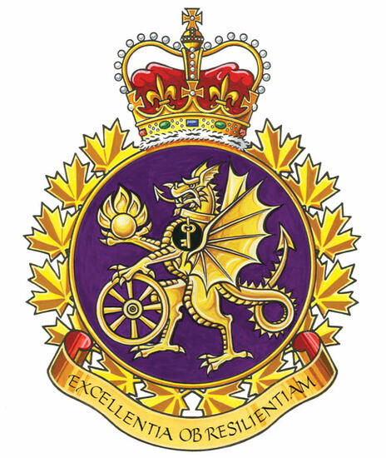

Materiel Support Group Report

The Materiel Support Group UMCC to meet in January, 2026.
Management Co-Chair Col Arcouette, Civilian Co-Chair James Potts.

CMSG Accountability, Responsibility and Authority (ARA) Framework

This document was designed to formalize the way Terms of Reference (Canadian Armed Forces) and Key Function Listings (Public Service Employees) are used

Generally, civilian employees have a Standardized Job Description (SJD) and a Statement of Duties that is also reflected in the Work Objectives section of the Public Service Performance Agreement (PSPA).

To date, there has not been any reported impact of this initiative. The ARA does not supersede the aforementioned documents.

Ammo Depot Training

The issue was raised at the UNDE Local Presidents Conference (LPC) that training is not being made available to civilian members, and, as such, our members are not able to access the same career opportunities that their military counterparts can. There was a suggestion to reestablish the Ammo Working Group in order for common issues to be raised and addressed across all the depots. A member from each CFAD (Bedford, Angus, Dundurn, Rocky Point) has been identified to sit on this working group. Meetings will commence shortly.

Meetings

There has not been a UMCC in quite some time. I am working to reestablish the committee and ensure that meetings are held at regular intervals as per the committee’s terms of reference.

Respectfully submitted,

James Potts
Vice-President – UNDE Ontario Region
Alternate UNDE Executive Vice-President

