ADM Infrastructure and Environment UMCC
ADM(IE) UMCC
Report for the National Executive meeting December 2025

ADM(IE) UMCC meetings were 23 June and 14 November.
ADM(IE) Peter Hammerschmidt, MGen Nicolas Pilon, COS(IE) and Col Fortin Comd RP Ops Gp HQ.

Financial Update – June UMCC
Announcement of Defence Investments (cash): Action
(1) Infrastructure Sustainment – $8.8B over 5 years, $69B over 20 years;
(2) Ammunition Capacity Expansion – $1.5B over 5 years, $5.8M over 20 years;
(3) Range and Training Infrastructure Rehab – $2.6B over 5 years, $11.4B over 20 years;
(4) Naval Infrastructure – $1.2B over 5 years, $18.1B over 20 years; and
(5) An important gain in this Government’s investment, it is an allocation of 1246 FTE and associated SWE envelop for CF RP Ops Gp to support Infrastructure Sustainment initiative.

This money will be on top of the Our North, Strong and Free (ONSAF) funding received.

November UMCC -
See resources Powerpoint – UMCC Defence Spending ONSAF and NATO 2%
Powerpoint Overview-
- ONSAF – Infrastructure Maintenance and Renewal (Slide 3)
- New Defence Investment – NATO 2% (Slides 4-9)
- Summary (Slides 10-11)
- CF RP Ops Group – FTE growth (Hand-off)

ADM(IE) 7 yr FTE Profile (slide 11)
Overview:
- Building on ADM(IE)'s existing workforce of 3,228 staff, these new FTEs will help to stabilize and sustain DND's real property portfolio.
- ADM(IE) will continue to seek additional funding and resources, as required, to support its workforce as the CAF grows and as we strive to improve DND's real property portfolio.
- To address historic underfunding in operations, 1,356 of the 1,837 new FTEs will be in CF RP Ops Group.

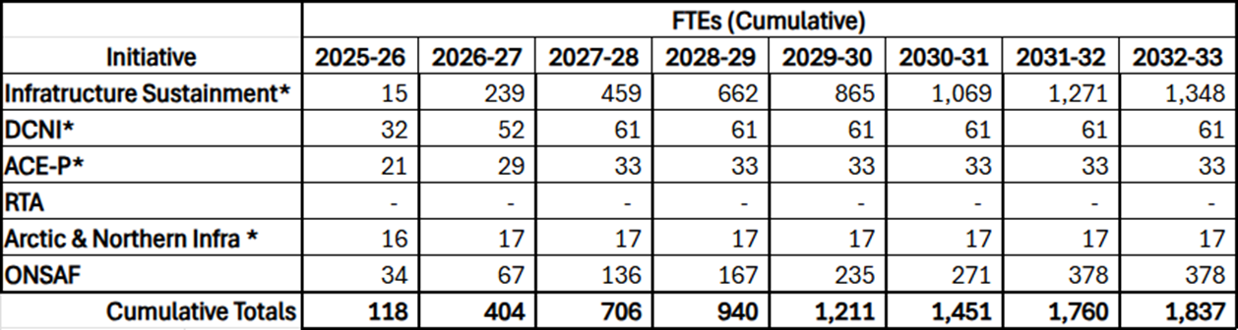

* Incremental FTEs earmarked (2026-27+), pending final Treasury Board decision.
Note: Additionally – not listed here:
- $10M in SWE secured through DND’s Investment and Resource Management Committee (IRMC) to address CF RP Ops Group staffing shortfalls.
- NORAD Modernization funding, which includes projects sponsored by other L1s and supported by ADM(IE) ~198 FTEs.

See Resources Powerpoint – CF RPOPs Group Brief
Slide 3 - Senior leadership support and recognition, alongside the additional funding represents a once-in-a-generation opportunity to rebuild the CF RP Ops Gp into a modern, sustainable, and mission-driven organization. However, success will hinge on:
- Thoughtful sequencing of growth and reform;
- Strong governance and accountability mechanisms; and
- Sustained engagement and communication with the workforce and Defence partners.

Evolution team Update Col Fortin Email - New chapter in the modernization of CF RP Ops Gp. With the foundational work of the Evolution Team now complete, and with the stand-up of the new HQ structure, responsibility for modernization will now be fully integrated into our core structure of Program Management & Integration, Operations, and Support.

Considering increased funding and growing momentum, modernization will be led from within, embedded in our day-to-day efforts to improve how we serve the organization.

1.Evolution Team Transition
Effective 1 October 2025, the Evolution Team shifted to a new operating model. Their work has been instrumental in getting us to this point and will now be carried forward by the broader HQ.
2. A Look Back
Over the past two years, the Evolution Team has conducted various stakeholder engagements and delivered:
- A Modernized Service Delivery Model
- A Current State Assessment Dashboard
- A Cultural Analysis Report
- Our Culture Evolution Plan
- Various analysis, guidance documents, and strategies
These tools now form the foundation of our transformation and will continue to inform how we move forward.
3. What is Next
Here is how we will manage the transition:
- Modernization tasks will be integrated into the Program Management, Operations, and Support teams.
- Two deployable positions reporting to the Deputy Commander will remain in place to support special projects across all three teams. They are intended to be staffed as project needs require – temporarily and from within the CF RP Ops Gp.
- The HR functional analysis will continue independently, supporting workforce planning and development. (Ops Order to follow)
4. Who is Doing What
Evolution Team
- Finalize documentation and ensure records are available to the Command team
- Brief the incoming HR Functional Analysis Lead, Alex Lemieux
CF RP Ops Gp Command Team
- Archive outputs for future use
- Manage the two deployable positions
- Oversee the HR functional analysis
- Integrate modernization activities into the HQ structure and operation
Program Management & Integration, Operations, and Support Teams
- Take ownership of modernization work within their areas
- Collaborate with deployable resources as needed
- Align with the Centre-Led model and client service excellence

See Resources Powerpoint – CF RPOPs Group Brief
CF RPOPs Group ReOrganization (slide 9)
Executive Summary
- 10x J-Heads consolidated into 3x Directors: Operations, Programs, and Support
- Primary Aim is better integration with other ADM(IE) L2s – many are unfamiliar with J-Code structure
  - Currently other L3’s have between 2-5 contact points within the J-Codes, new structure provides one primary POC for each L3.
- Secondary benefit is improved depth and focus as well as maximizing existing senior leadership in the HQ
  - Example: Program Management is currently shared between 3x J-Codes that would consolidate under one.
- Execution achievable within months, anticipated to be relatively seamless. Prioritized within current ONSAF FTE forecast.
- Civilian Director planned for Program – creates continuity and development benefits, but classification risks (AS vs EX)

New Structure at a Glance

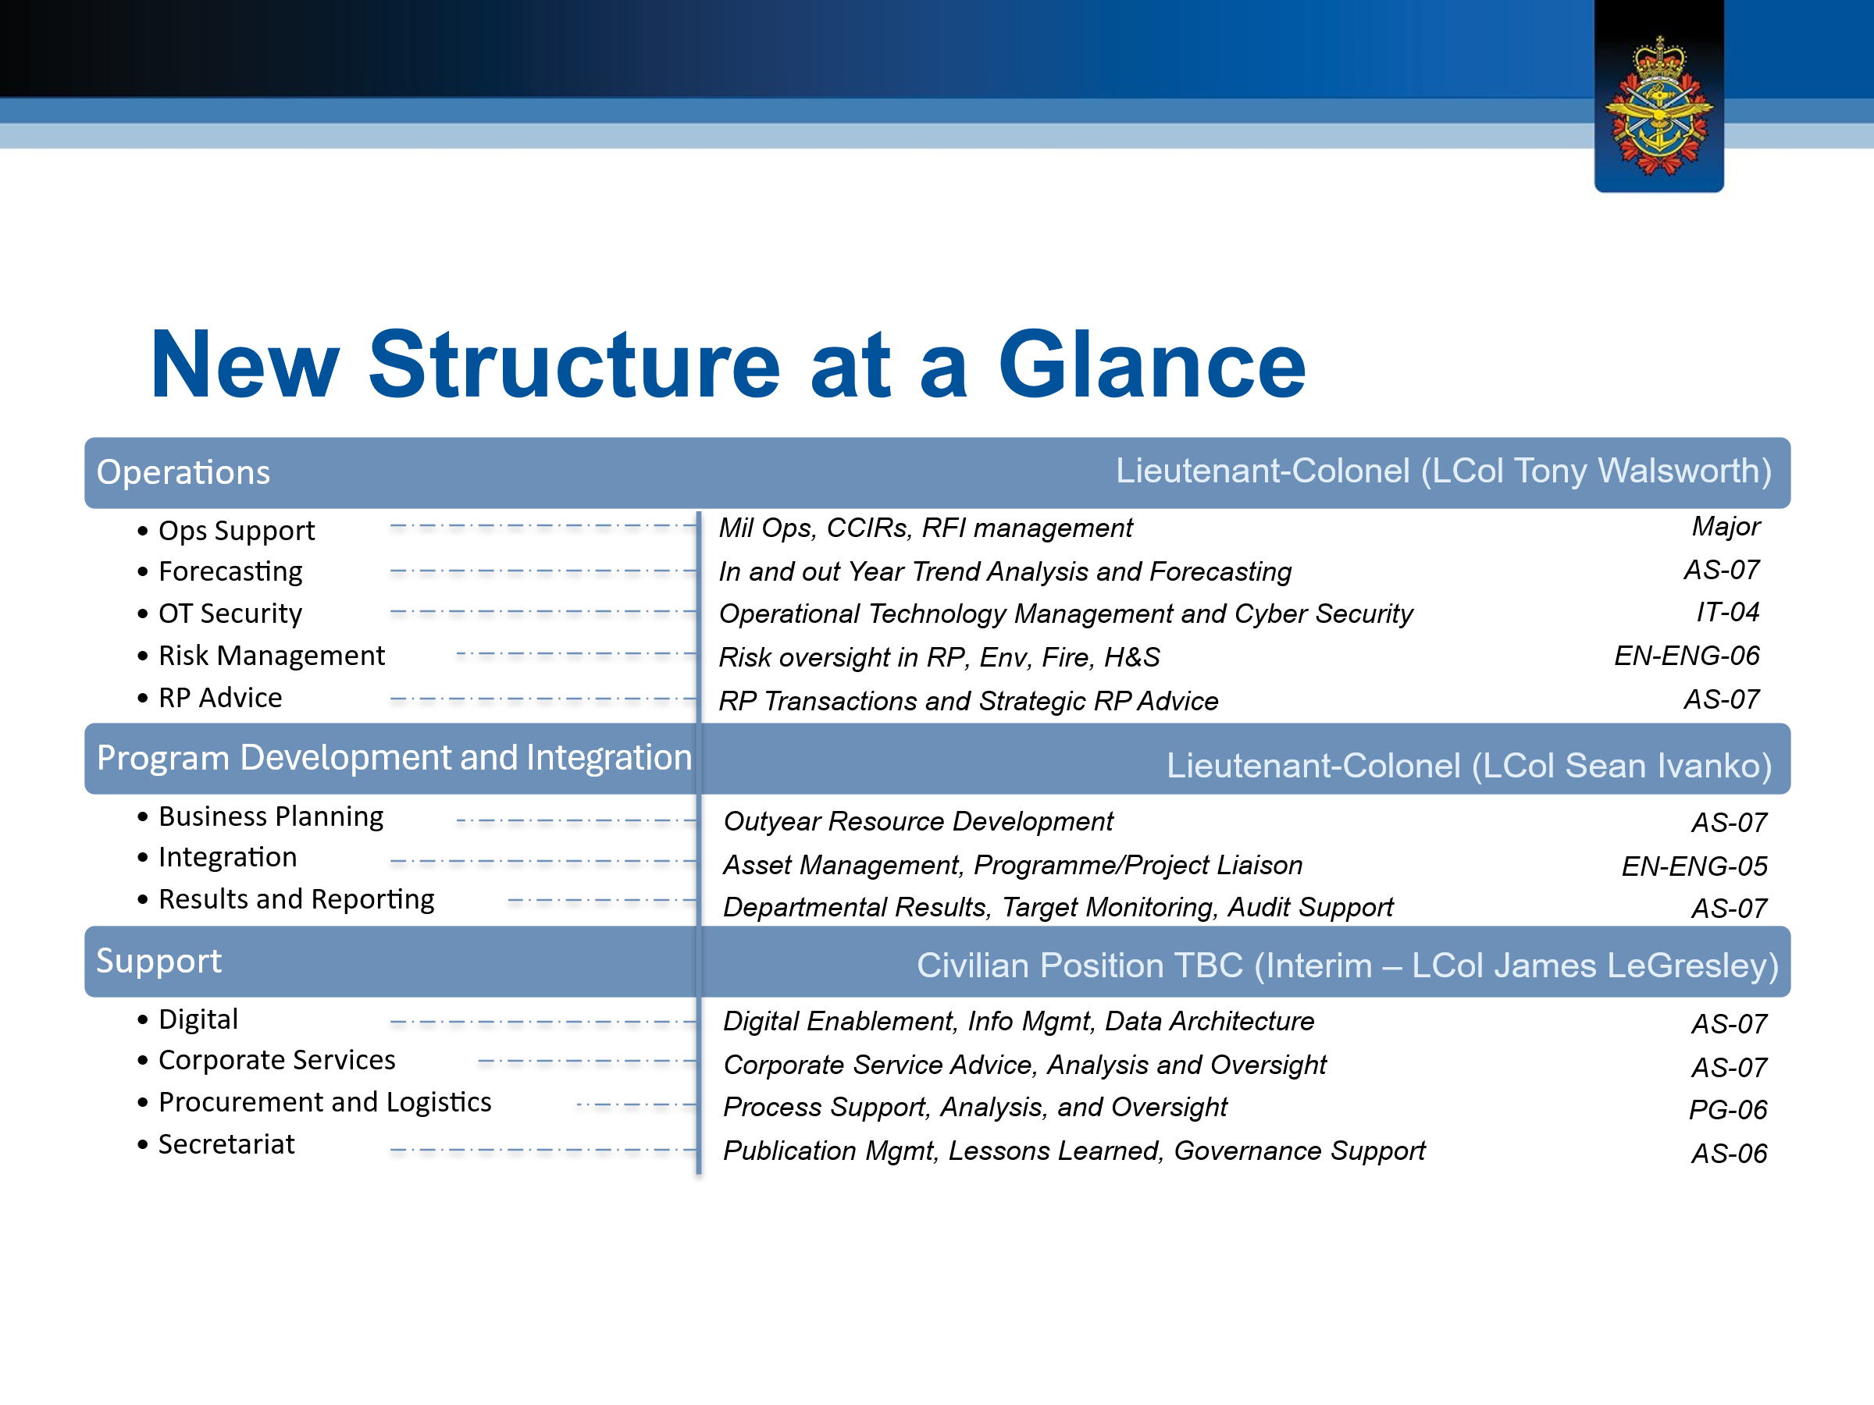

DCC –
Col Fortin stated there will be more Facility Management contracts.
See Resources Powerpoint – CF RPOPs Group Brief (Slide 2)
Our Plan
Work Force Investment
- All domain increase (incl. Shops)
Maximized Ops Delivery
- Facility Maintenance Contracts, Project Management, Contracts
Maximized Project Delivery
- Construction Management, Modified-Design Build, Design-Bid-Build and Technical Support Services
All Tools On Hand Approach
- DCC
- PSPC
- CORCAN
- Delegations

Quality control of contractors is crucial for workforce. With the influx of $9B funding, there is a pressure to spend quickly on infrastructure and a need for projects to be ready, so at the front end, will require contractors; expect contracting support to decrease as hiring increases. Staffing takes time, so DCC is essential at this stage. There has not been consistent funding, but with this, the team can plan 5-10 years in the future. Extra DCC services are needed for project management and contract management to deliver better infrastructure and fix the foundation (state of the portfolio).

There is not enough SWE & FTE so transforming portfolio into increasing capacity, delegations of authority, and using all the tools which means contracts and DCC.

Unions secured a separate meeting to receive clarity on the mandate of DCC and discuss stop using DCC for work outside of its mandate. The Service Level Agreement (SLA) handbook and contracting authority regulations need to be followed. This meeting will also talk about quality control and holding DCC accountable.

Bargaining – Discussed with the ADM the pay studies and the issue of low wages compared to the private sector. Asked for Management to ensure TB is made aware of pay issues within ADMie and Trades.

Apprenticeship – Reminder that this program did work in the past and should not be forgotten as a way to secure PS positions.

Respectfully submitted by
Mona Simcoe Marcelo Lazaro
VP MB/Sask VP BC
Co-Chair

