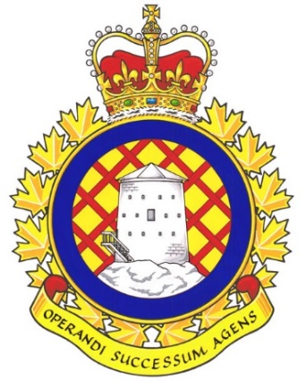

Real Property Operations Unit (RPOU) Ontario Report

There have been 2 UMCC meetings since the last NE meeting. They were held in July and October 2025.

UNDE members on this committee include:
Brian Duck, Local 00621 Borden
Dan Barrett, Local 00625 Toronto
Steven Yashinskie, Local 00629 Petawawa
Nate Buisman, Local 00635 North Bay
Cheryl Gough, Local 00637 Trenton
Chris Snooks, Local 00641 Kingston
James Potts, Co-Chair

Vacancy Management, SWE, and O&M
Vacancy Reports continue to be provided at regular intervals without the need to make a request. These reports serve as the benchmark when making requests from other parts of the DND organization. It is a standing item and is produced by the committee secretary every few months. Staffing is expected to fill some vacant positions across the organization. The SWE allocation for this fiscal year is considerably higher than it was last year as a result of the government’s commitment to increase defence spending. There is significant growth forecast for Ontario RPOU Detachments over the next 7 years, with the majority of positions being created and/or filled over the next 4. O&M has also increased, and preventative maintenance is now being performed across the region.
Red Seal
Det Borden was in the process of hiring a Painter who does not possess an Interprovincial Red Seal. While they assured me that they did not have any plans to staff this position indeterminately with a candidate who did not have a trade certification, this is exactly what they intended to do. After assuring me that they would only place this member in a short acting (less than 4 months) position while he earned his Red Seal, a Notice of Consideration has seen been released showing an acting period of 1 year. I informed the OC and CO that there is an apprenticeship program available if that is their intent, but they are not to reduce the requirements of a red Seal Trade position. The member has since been hired on the condition that he earn his Red Seal within 1 year. There is also an advertised process, though a Red Seal is listed as an “asset” and not an “essential” qualification. The CO of RPOU(O) has agreed that the Red Seal will remain the standard and that individuals who possess a Red Seal will be hired before anyone who does not hold that qualification.
This has not been an isolated incident. Other trades and Contracts Inspector positions have been posted in the same fashion. The CO RPOU Ontario agrees with the requirement for a Red Seal. RPOU(O) is in the process of increasing their use of the apprenticeship program as well in order to assure that there are sufficient candidates for the positions available.
Self-Help
There have been a number of requests for self-help projects, mostly related to painting. There have been instances of self-help projects that proceeded without proper authorization. RPOU Ontario was requested to show little tolerance for any unit that proceeds with a self-help project without proper authority to do so. We are also monitoring closely to ensure that self-help isn’t being used in lieu of having our members perform the work where the capability and capacity exist.
Standby/Callback
UNDE Local 641 President Kingston said some of his members raised concerns about changes in standby. Due to SWE pressures, the use of Standby is now very closely monitored. The worry is that there will now be gaps where no one is available to respond in the event of an emergency. Some Chief Operating Engineers from heating plants had been receiving standby pay every day as a means of increasing their base salary. This practice has been ceased as of the beginning of the calendar year.
Water Quality and Legionella Testing
Water tests are conducted throughout the year. In most instances, municipal water is being used and is tested by the municipality up to the point where it enters Base/Wing lines. The issues generally arise from old pipes in DND’s aging infrastructure. Testing results where lead or other hazardous materials have been detected will be shared with UMCC members.
Legionella testing of standing water and pipes is ongoing. This stemmed from an incident in Kingston, Ontario, where a member contracted Legionnaire’s Disease after working in an area with standing water in the basement of a DND building.
Self-Inspection
There is a potential conflict of interest in the way work is being monitored in Toronto. DCC and Black and McDonald (FM Contractors) are being contracted and supervising themselves. CO RPOU Ontario asserts that Compliance Inspectors would not risk their licenses by providing preferential or favourable treatment to the contractor as a trade-off for more service contracts.
Contracting In
There is the potential for grass cutting to be returned to the Public Service. DVP Ontario, Chris Snooks, is following up with OC Det Kingston.

The next meeting of the RPOU Ontario UMCC is scheduled for January 2026.

Respectfully submitted,
James Potts
Vice-President – UNDE Ontario Region
Alternate UNDE Executive Vice-President

