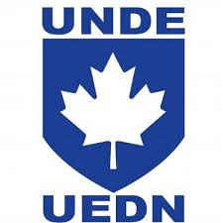

Real Property Ops Unit - Quebec
Date : | April 1, 2025 – December 1, 2025
VP Qc: | Johanne Rouillard

- Minutes of April 9, 2025 meeting see ANNEXE C.
- Minutes of October 31, 2025 to follow.
- Highlights :
  - Increase of 200 positions to come within 5 years.
  - Maintenance deficit of $2 billion. Outsourcing will have to continue despite the addition of new positions in order to reduce the deficit.
  - Training unit created to enable employees to receive training and trade qualifications in a timely manner.
  - St. Jean thermal power plant modernization project. Employees have been consulted. A visit to Windsor is planned so that employees can see a modernized thermal power plant and ask questions of the employees who work there.
  - Employees will be consulted regarding FM contracts. Possible challenges with the availability of industries in the regions.
  - CorCan: Tool of last resort. The work will first be presented to the workshops. If the employees cannot do the work, there will be a request for a contract (subcontracting). If the contract cannot be subcontracted, RPOPS will turn to CORCAN's services. Members reported a lack of communication with CORCAN. Members want to have a point of contact with CORCAN management so that work is not duplicated.

Respectfully submitted, Johanne Rouillard

