ROYAL CANADIAN AIR FORCE RCAF L1
UNION MANAGEMENT CONSULTATION COMMITTEE
Report to the NE meeting December 2025

Last meetings held 2 Jun 25 and 14 Nov 25.
Comd RCAF LGen Jaimie Speiser-Blanchet, DComd RCAF MGen Denis O’Reilly
1 CAD -1 Wing Kingston, 2 Wing Bagotville, 3 Wing Bagotville, 4 Wing Cold Lake, 5 Wing Goose Bay, 8 Wing Trenton, 9 Wing Gander, 12 Wing Shearwater, 14 Wing Greenwood, 19 Wing Comox, 22 Wing North Bay, ATESS - Aerospace and Telecommunications Engineering Support
2 CAD -15 Wing Moose Jaw (2 CFFTS, 3 CFFTS, 431 Sqn), 16 Wing Borden (CFSATE, CFSACO, RCAF A), 17 Wing Winnipeg (CFSSAT, Barker College, 402 Sqn, RCAF Band, Det Dundurn), 2 CAD HQ (CFASC)
3 Canadian Space Division Commander - 7 Wing, 3 CSD HQ

The Comd of RCAF has not been to the last two meetings. The last meeting of the RCAF L1 was not a productive meeting. The DComd requested a meeting 15 minutes before the UMCC with Mona Simcoe as he thought she was their HR-Civ representative. The DComd at the start of the meeting asked where their HR-Civ representative was and that this meeting needs to have them present. The meeting was very heated with the DComd continually saying that HR-Civ needs to be consulted before a decision can move forward. UNDE informed management that it is managements right to manage and that HR-Civ does not make the decisions at this table.

FAcT Update- No meetings with the UNDE have taken place with FAcT SME, the Operational Implementation Working Group (OIWG) or at the L2 level. UNDE questioned why once again no meetings have not taken place to keep the union informed. UNDE stated at the L2 UMCC they say they are not informed of FAcT progress so have no information. The L1 had endorsed union involvement up to the meeting on 14 Nov. The DComd stated he was Commander in Moose Jaw and was part of the planning of FAcT. The DComd stated that it is not for the union to have meeting with FAcT. If the union has questions they should be asked to him, and he will communicate further to then provide the answers to union. UNDE stated that at every L1 UMCC since the start in 2021, they have been told they can have a meeting. The DComd stated that he did not believe that was the case. The DComd had obviously not read past minutes and was uninformed how a UMCC meeting worked. When talking about the contracts at Moose Jaw the DComd stated that he felt contracting is cheaper than PS employees. UNDE realized the frustration building and decided to move to the next agenda item. Noting that no one else at the table stepped in to support or clarify UNDE’s understanding. A separate meeting will be requested by UNDE with Commander of the RCAF.

Contamination Environmental Concerns –
Directorate of Environment and Operational Sustainability (DEOS) Ms. Wheeler pushed communications about the Wing Contaminated Site Program to all Wing Environmental Officers to ensure appropriate communication with Wing OH&S Committees. Ms. Wheeler confirmed that this messaging was completed and has responded to some follow-up queries. Ms. Wheeler share the environment plain language reports. UNDE did question some of the results of an Environmental assessment conducted at 15 Wing. Several items were indicated as having exceeded the associated testing limits. Ms. Woodhouse indicated that most of the exceeded limit items were related to the most stringent standards having been applied, specifically related to protecting drinking water. Since 15 Wing is on a municipal water system, these standards were not applicable. Ms. Simcoe asked whether compounding effects were considered by Director of Contaminated sites (DCS) when reviewing contaminants and if several substances were present, could the effects of each have a compounding effect. Ms. Woodhouse did not believe that compounding was reviewed. Ms. Woodhouse believes that since the variables associated with each substance are so different that compounding would not be a consideration.
BGen Robidoux queried about who owns the communication plan and what the process is. Ms. Wheeler will work with ADM(IE) to confirm and inform the unions. Ms. Wheeler to provide information on the communication plan for contaminated sites.

DCS provided update to the RCAF L1 meeting that testing was done on the external property in preparation for FAcT.
Phase I Environmental Site Assessment (ESA) – March 2022
Phase II Environmental Site Assessment (ESA) – October 2023
Supplemental Phase III Environmental Site Assessment (ESA) – September 2024
The National Classification System for Contaminated Sites (NCSCS) scoring was done again for all five areas in the Supplemental Phase III ESA, considering the re-screened data. All areas received a classification of 2 or lower. NCSCS scoring is used to prioritize contaminated site work based on risk.

National Classification System for Contaminated Sites:
Class 1: High Priority for Action (Total NCSCS Score greater than 70) The available information indicates that action (e.g., further site characterization, risk management, remediation, etc.) is required to address existing concerns. Typically, Class 1 sites show a propensity to high concern for several factors and measured or observed impacts have been documented. (Note, this category was previously called “Action Required”.)
Class 2: Medium Priority for Action (Total NCSCS Score between 50 and 69.9) The available information indicates that there is high potential for adverse impacts, although the threat to human health and the environment is generally not imminent. Typically, for Class 2 there is no direct indication of off-site contamination; however, the potential for off-site migration tends to be rated high and therefore some action is likely required. (Note, this category was previously called “Action Likely Required”.)
Class 3: Low Priority for Action (Total NCSCS Score between 37 and 49.9) The available information indicates that the Site is currently not a high concern. However, additional investigation may be carried out to confirm the site classification. (Note, this category was previously called “Action May Be Required”.)
Class N: Not a Priority for Action (Total NCSCS Score less than 37) The available information indicates there is likely no significant environmental impact or human health threats. There is likely no need for action unless new information becomes available indicating greater concerns, in which case, the Site should be re-examined. (Note, this category was previously called “Action Not Likely Required”.)

At the Nov UMCC, UNDE discussed the article by CTV “Forever chemicals in North Bay and across Canada” regarding North Bay contamination concerns and the timeliness of reporting to public service members. The DComd asked for a further look into the North Bay article.

Language Requirements – 3 Canadian Space Division Commander expressed the difficulty in hiring in the space technical division due to language requirements. Mona Simcoe agreed that language requirements for supervisors will prove difficult for some technical trades and that the lack of language training is frustrating. Compounding this issue is that the federal government is mandating the language requirements but that the education is provincially managed.

FTE Staffing Vacancies and SWE Overview
RCAF Growth –
June UMCC highlighted the expected RCAF growth to 2040. To assist with the planning and integration of the PS into the RCAF HR plan, they are hiring an AS06 civilian HR manager and has obtained ADM (HR-Civ) support through the Enhanced Client Support Services Model (ECSSM). Management briefed the members on the PS draft growth plan for the next three years, which includes 83 positions this year, 63 in 2026, and 32 in 2027. Management then tabled the projected growth plan for the next 20 years, that will enable the onboarding of new capabilities and hiring of hundreds of new PS employees. UNDE asked about the contracted services for work that should be completed by PS employees. BGen Robidoux indicated that the RCAF was directed to terminate several contracts in the last year and that future RCAF requirements would require a balanced approach to include hiring PS employees and future contracts.

UNDE mentioned the continued reliance on cleaning contracts as one example of something that the RCAF could convert to PS employees. UNDE stated it would be beneficial to evaluate the cost between contractors and PS employees, given that it is frequently more cost effective to hire PS than to pay contractors. PIPSC indicated that the DND spent $5.2 billion last year on contractors but only $2.1 billion on PS employees, and that this was one of the worst ratios in the government. PIPSC also noted that there are many circumstances where contractors are hired for a short-term project but never leave, often making themselves indispensable. The increased use of contractors has led to some 3000 grievances from PS employees. PIPSC recommended that contractors be used to sunset old systems while PS employees be trained on and implement the new systems. He also recommends more funding for training existing employees as a more proactive HR measure. BGen Robidoux reminded the group that the RCAF does not approve its own SWE to be able to hire PS employees and while they can convert funds to offset limitations, the RCAF is under resourced in every fund and that conversion taxes are frequently required. There are some items for which a contracted solution, such as some 2nd and 3rd line maintenance for aircraft, is optimal. The RCAF stated they carefully consider each request and selects the most appropriate solution while considering all its priorities. BGen Robidoux closed the meeting by reiterating the RCAF’s commitment to improve its HR processes and stated once the RCAF’s expected growth is realized and new capabilities are onboarded, the RCAF will be an employer of choice.

Nov UMCC
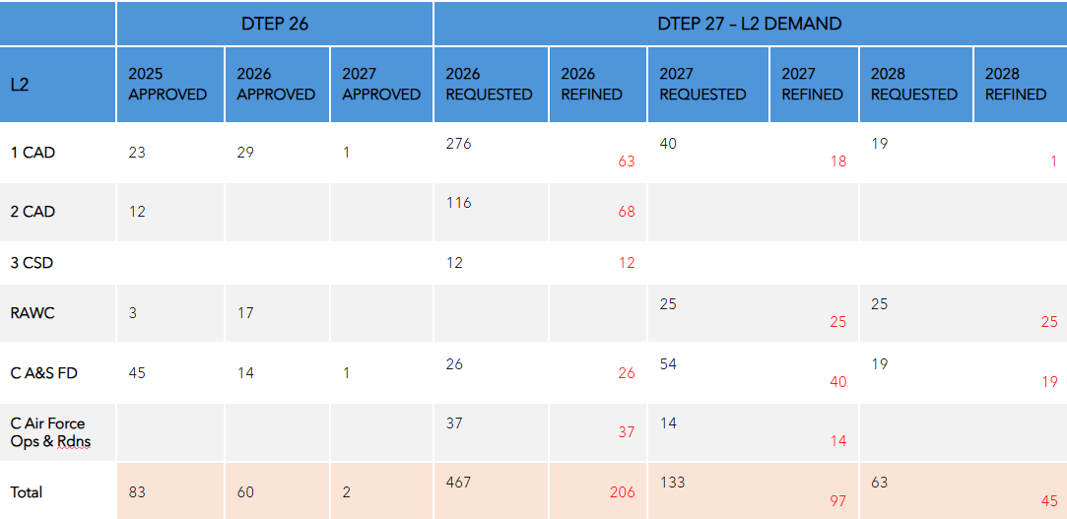
SWE will be 100% spend this fiscal year.

Vacancy Reports – Management stated on agenda presentation that work between the L2 and L3 is improving staffing vacancy management and forward planning. L2’s are investigating the generation of a vacancy report to be included with LMCC minutes. During the UMCC the DComd expresses managements perspective of challenges on classification and tracking vacancies. He stated that without HR attending he doesn’t know what management is allowed to share or why. Col Proteau then stated that management “will only share vacancy reports if they are told to do so, Sir.”

Questions for FAcT – At the end of the UMCC the DComd stated that he can be difficult and he is willing to work on questions to help the union get the answers they are seeking regarding FAcT and other various projects.
RCAF L1 UMCC Questions – Response due by end of January 2026

- What is the current policy with respect to HR planning for contracts like FAcT, specifically the choice between PS Employees and contractors?
  - Is there any policy that directs the level of consultation between L1s and their respective unions in the early stages of HR planning?
  - If not, is there a plan to develop one?
- Given changes to funding levels and predicted growth of the RCAF PS, has a business case analysis been done to challenge the cost effectiveness of contractors vs PS employees?
- Is there a policy that does/does not direct how in-service support contracts are drafted in the future?
- Are there plans to upskill particular PS employee positions as part of RCAF modernization projects?
  - Is there a list of identified capabilities that the RCAF is planning to abandon? (ex. RP Ops capacity building)

Respectfully Submitted by
Mona Simcoe Co-chair VP MB/Sask & James Potts VP Ont

