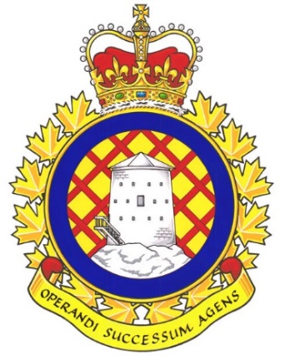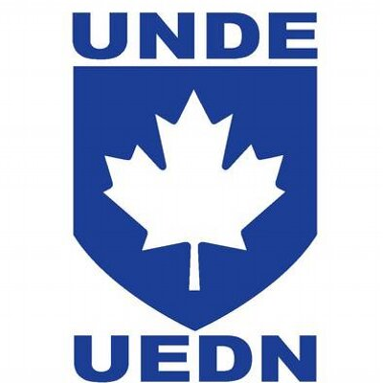

Real Property Operations Unit (RPOU) Ontario Report

There have been 2 UMCC meetings since the last NE meeting. These were held on June 11th and September 19th.

UNDE members on this committee include:
Jayne Pollock, Local 00621 Borden
Dan Barrett, Local 00625 Toronto
Steven Yashinskie, Local 00629 Petawawa
Ken Bovair, Local 00635 North Bay
Cheryl Gough, Local 00637 Trenton
Chris Snooks, Local 00641 Kingston
James Potts, Co-Chair

Vacancy Reports continue to be provided at regular intervals without the need to make a request. These reports serve as the benchmark when making requests from other parts of the DND organization. It is a standing item and is produced by the committee secretary every few months.
RPOU Ontario provided a general update on their progress into the cultural assessment being conducted on the organization. The classification realignment and reorganization initiatives are proceeding, but the process is slow. The hope is that the final outcome will result in classification upgrades for members who are performing the same duties as members with higher classifications in different parts of the organization.
I have received reports that many supervisory positions within RPOU Ontario have been “locked” and can not be used even though members have been asked to perform acting duties. After some research, including some conducted by local management, it was determined that this has been done by Director, Civilian Classification and Organization (DCCO) as a result of an attempt to realign the differential allotments to accurately reflect the scope of supervisory duties as well as the general number of people being supervised. This situation is supposed to be resolved shortly and all members will receive remuneration for their time spent acting in a locked position.
Contracting out is always a chief concern. RPOU Ontario has released a draft of an updated “self-help” policy (see attached document) that has caused much concern. Essentially, Units would be in a position to use their own funding to contract out infrastructure work that RPOU would normally carry out. It also grants users the permission to conduct their own infrastructure work if the local RPOU detachment signs off on the plan. In a meeting with the OC of RPOU Det Petawawa, UNDE expressed their concerns and warned that this policy will likely result in the demise of RPOU as an organization.
The SWE allocation for this fiscal year is only slightly higher than it was last year (to account for pay increase tied to collective agreements. This does not allow for an increase in the size of the workforce. O&M has also been cut and it is very unlikely that RPOU will be able to more with less without there being a toll on the existing workforce. Current vacancy management reports list approximately 129 vacant positions within the organization.
RPOU is currently undergoing a Cultural Assessment, which will be tied to the RPOU Ontario Code of Conduct that is also being developed. The results of the 2019-2022 Public Service Surveys are being used as part of the initial framework. This will be straight forward and will fit on an 8 ½” x 11” sheet of paper and will clearly state what behaviours and characteristics management expects from all members of RPOU as part of their day-to-day work and in their role. These documents will not supersede the Code of Values and Ethics for DND and the CAF. RPOU is looking for a more clear and concise version of an existing document.
I had to reiterate the issues pertaining to the contracting of cleaning services. I used the Petawawa example of what can happen when you have no control of the staff and supervisors, and are stuck with a company who chooses not to perform the work as per the contract. It was shocking that management was only peripherally aware of the issues. It was clear that no one had drafted, or even seen, a business case related to contracted cleaning services. I communicated that this was yet another example of management making decisions without consultation with the union, and that consultation must happen prior to decisions being made.
Det realignment is progressing at a slow pace. After working on this for a year (in collaboration with Classification, Staffing and others), we have recently finalized a Charter with Classification which has been signed off by the Commander. The concept is to align based on similarities and ensure equal pay for equal work based on groups and levels and the work being done across the Formation. Realignment is looking backwards to stand up of CF RP OPS and ICCTs when positions were received in 2016. Complexities is that we have 7 Regions, 31 Dets/Sections and over 3200 positions which includes Military positions. Military positions are being included as we need to review CO and OC positions and create “at level” Civilian positions in case we have gaps there. RPOU intends to carry out their evaluation and devise a framework prior to sharing information with the union. Once again this is an example of a lack of proper and meaningful consultation.
Det Borden was in the process of hiring a Painter who does not possess an Interprovincial Red Seal. While they assured me that they did not have any plans to staff this position indeterminately with a candidate who did not have a trade certification, this is exactly what they intended to do. After assuring me that they would only place this member in a short acting (less than 4 months) position while he earned his Red Seal, a Notice of Consideration has seen been released showing an acting period of 1 year. I informed the OC and CO that there is an apprenticeship program available if that is their intent but they are not to reduce the requirements of a red Seal Trade position.
The contract owned by Tech Services was not being watched closely and as a result the contract dollar amount was exceeded and had to be re-written. As timelines were not met, PSPC could not just do an extension; hence problems in Petawawa for the past 6 months.
Pest control is not the responsibility of civilian building occupants. RPOU detachments are responsible for rodent/pest control. PMed has a role to play as well and there is much confusion between policies and unofficial policies.
Health and Safety is the number 1 for RPOU Ontario, but even health and safety related work orders are being triaged for priority due to budgetary constraints. This means that H+S matters can remain outstanding indefinitely.
The next meeting of the RPOps Ontario UMCC is scheduled for January 2025.

Respectfully submitted,
James Potts

