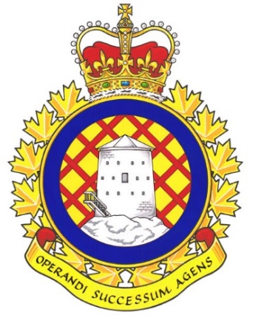

Real Property Operations (RPOps) Ontario Report

There have not been any UMCC meetings since the last NE meeting.

UNDE members on this committee include:
Jayne Pollock, Local 00621 Borden
Dan Barrett, Local 00625 Toronto
Steven Yashinskie, Local 00629 Petawawa
Todd Brisson, Local 00635 North Bay
Cheryl Gough, Local 00637 Trenton
Chris Snooks, Local 00641 Kingston
James Potts, Co-Chair

Vacancy Reports continue to be provided at regular intervals without the need to make a request. These reports serve as the benchmark when making requests from other parts of the DND organization. It is a standing item and is produced by the committee secretary every few months.
A cultural assessment is being undertaken across RPOU Ontario. The interim findings were discussed though the endeavour is still in its infancy. The organizational paradigm is being assessed and evaluated. Staffing actions are ongoing to fill positions related to this cultural assessment as well as the classification realignment and reorganization initiatives. These positions have been advertised on jobs.gc.ca. The results of all of these initiatives will remain standing agenda items at the UMCC, with members of each committee delivering the updates first-hand.
Contracting remains a chief concern and is on the agenda for the ADM(IE) UMCC being held on May 17th, 2024.
Local 00621 Borden is experiencing an issue concerning a grievance that was upheld but remedies were never instituted. This issue involves members working in the Central Heating Plant. I am working directly with the Local VP to ensure that appropriate actions are taken. ADM(IE) is proposing to eliminate standby pay rather than working on a way to distribute standby pay in an equitable manner across the organization. This is a topic for discussion at the AMD(IE) UMCC.
There is still no staffing freeze reported for RPOU Ontario at this time though there continues to be an alleged SWE shortfall.
The next meeting of the RPOps Ontario UMCC is scheduled for June 18th, 2024. This will coincide with a change of command with the incoming CO of RPOU Ontario.

Respectfully submitted,
James Potts

