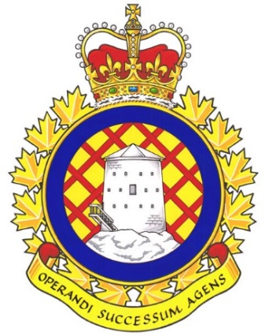

Real Property Operations (RPOps) Ontario Report

Since the last NE meeting, RPOps Ontario held a UMCC meeting on December 12th, 2023.

UNDE members on this committee include:
Jayne Pollock, Local 00621 Borden
Dan Barrett, Local 00625 Toronto
Steven Yashinskie, Local 00629 Petawawa
Todd Brisson, Local 00635 North Bay
Cheryl Gough, Local 00637 Trenton
Chris Snooks, Local 00641 Kingston
James Potts, Co-Chair

Vacancy Reports continue to be provided at regular intervals without the need to make a request. These reports serve as the benchmark when making requests from other parts of the DND organization. It is a standing item and is produced by the committee secretary every few months. The latest report shows many vacancies as well as positions set to be abolished. These positions were said to be set to be abolished after newer, higher-classified positions are created in their place.
A cultural assessment is being undertaken across RPOU Ontario. The interim findings were discussed though the endeavour is still in its infancy. The organizational paradigm is being assessed and evaluated. Staffing actions are ongoing to fill positions related to this cultural assessment as well as the classification realignment and reorganization initiatives. These positions have been advertised on jobs.gc.ca. The results of all of these initiatives will remain standing agenda items at the UMCC, with members of each committee delivering the updates first-hand.
Contracting remains a chief concern. Local 00625 is looking into the feasibility of returning many maintenance capabilities in-house. The argument is that there is currently no preventative maintenance being performed and systems, such as the boiler heating system, are falling into disrepair. Failure of such systems is inevitable without preventative maintenance and will be catastrophic when they occur. Cleaning would be a simple service to return in-house, resulting in a higher service standard and likely a lower price tag. There would be the opportunity for synergy between Dennison and DRDC, located across the road, where Public Service employees could be maintained as a cadre of support and trades services within a minimal footprint. Servicing the small units located outside of the primary hub would still prove to be challenging due to the distances involved.
OC RPOU Petawawa and CO RPOU Ontario have been engaged to help address the issues currently unfolding with Toure Cleaning Services in Petawawa. Both have been pushed firmly on the need to eliminate contracted cleaning services and to contract these services back in to the Public Service. CFB Petawawa BComd is also onboard with this initiative though the decision will ultimately be made much higher due to the SWE implications.
There is no staffing freeze reported for RPOU Ontario at this time though there continues to be an alleged SWE shortfall.
The next meeting of the RPOps Ontario UMCC is scheduled for March, 2024. This will coincide with a change of command with the incoming CO of RPOU Ontario.

Respectfully submitted,
James Potts

