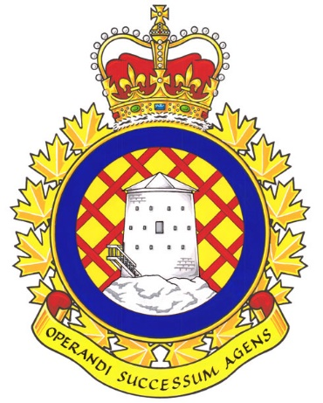

Real Property Operations (RPOps) Ontario Report

Since the last NE meeting, RPOps Ontario LMCC a meeting was held on July 21st, 2023.

UNDE members on this committee include:
Jayne Pollock, Local 00621 Borden
Dan Barrett, Local 00625 Toronto
Steven Yashinskie, Local 00629 Petawawa
Todd Brisson, Local 00635 North Bay
Cheryl Gough, Local 00637 Trenton
Chris Snooks, Local 00641 Kingston
James Potts, Co-Chair

Vacancy Reports continue to be provided at regular intervals without the need to make a request. It is a standing item and is produced by the committee secretary every few months. The latest report shows many vacancies as well as positions set to be abolished. These positions were said to be set to be abolished after newer, higher-classified positions are created in their place.
Health and Safety was discussed. Of specific interest is the asbestos and other hazardous materials inventory. The discovery of Legionella at CFB Kingston has triggered the development of a Legionella testing plan for all RPOU Detachments in the Region. For asbestos and other hazardous materials, tracking is currently being done at all detachments, but a standardized approach is being developed.
A team has been assembled to analyze the results and recommendations of the Deloitte study. They will work on this for the next year and implement the recommendations and report to CF RP OPS Gp HQ, who will provide updates directly to Command. An EVO Team is being set up to head-up this endeavour. This team is to be led by 2 AS06 positions, an EX 01 position, and a LCol. Solicitation for the civilian positions was done via an internal email to the RPOU detachments in the region. They are for a period of 4 months less a day.
The J1 is investigated all issues concerning delays in receiving overtime pay. Issue have now been resolved, though some of the more difficult issues remain outstanding. Concerns are now minimal.
RPOps Ontario is proceeding with a realignment of classifications. So far, AS positions have been created. Mapping of finance positions has been completed and sent for Classification. Procurement position mapping is nearly complete as is mapping for Trades positions.
Cultural assessment is being undertaken across RPOU Ontario. A regional meeting is scheduled for September where progress and findings are to be discussed. The organizational paradigm is being assessed and evaluated.
Strike pay issues on the employer side persist. These include pay issues for employees who were deemed essential, who reported to work, etc. A complete review is being conducted with an SFT specialist.
Reimbursement of professional fees was not happening in a timely manner but has since been rectified.
The next meeting of the RPOps LMCC is scheduled for October 5th, 2023.

Respectfully submitted,
James Potts

