ADM Infrastructure and Environment UMCC
ADM(IE) UMCC
Report for the National Executive meeting Nov 2022

The last meeting of the ADM(IE) was held on 20 May 22.
ADM(IE) is Rob Chambers.
MGen Horgan has now retired and MGen Martin Gros-Jean COS(IE) is his replacement who we will meet on 01 Dec 22. Col Henley is Comd for RP Ops Gp

NORAD Modernization and Continental Defence remains forefront within the department. Government of Canada will decide on options and expected a percentage of the work associated with this will fall to ADM(IE). NORAD modernization and continental defence are key aspects. ADM(IE) will play a significant role as there will be Indigenous, environment, and infrastructure aspects. Development of potential options continues.

Strategic Review is taking place in the NCR to consolidate the office footprint as a result of hybrid work environment.

Terms of Reference submitted and reviewed for next meeting.

Staffing Summary:
Additional SWE for 21/22 was not received. Vacant positions-certain positions were transferred to IE without funding during RP Centralization. There are currently 221 active or planned staffing actions taking place within ADM(IE).

Standby Pay: CF RP Ops Gp is experiencing a pressure of $10M in SWE and stand-by pay is adding to that pressure and slows down staffing. While attrition will help alleviate the pressure, it certainly will not eliminate it. In addition to this, there is concern that using military members to fill stand-by positions causes an us verse them situation so properly communicating the situation is important as a next step.

ADM(IE) Budget and SWE: Last year’s budget for ADM(IE) was $2.1B with SWE starting the year at $214M plus an additional $10M allocated for leave buy-out. For this year the budget for ADM(IE) is $2.1B with SWE increasing to $216.5M due to incremental pay increases. A copy of the FY21/22 and FY22/23 Budget and SWE report is attached with minutes.

Module 10 – Defence Construction Canada (DCC) - ADM(IE) Management Manual:
The purpose of this module is to outline the unique function of DCC and the relationship with ADM(IE). DCC is the contracting authority for most DND real property contracts with some negotiated involvement of Public Services Procurement Canada (PSPC). Although DCC has a functional relationship to the Minister of PSPC, DCC reports to a Board of Directors and executes most of its responsibility through a Memorandum of Understanding (MOU) with ADM(IE). In keeping with the distributed responsibilities within the IEMM this module has been developed and issued under the authority of the Vice President Operations (VP Ops) of DCC.

Deloitte:
The purpose of this study is to review how RP Ops Gp is conducting Facility Management (FM) within the formation initially focusing on how they implement and oversee contracts but also how they can be “organized to be more resilient with resource constraints and a growing portfolio.” “The intent is not to reduce the workforce but look to provide consistency and develop efficiencies in how DND manages real property.”
This is step one of the Organizational Design Review for RPOps.
Interview and workshops have been completed across the country.
Now analyzing initial insights and developing workshop materials.
Survey has been received by the RP Ops workforce.
Completed Gap Analysis. Articulate Final Recommendations.
Final Report is out for translation and will be presented to RP Ops units.

37% of the overall number of staff and members have responded to the survey

Region | Regular Force Members | Primary Reserve Members | Civilians | TOTAL  (Personnel) | Surveys Submitted to Date | Regional Completion %
CF RP Ops Gp – HQ | 17 | 0 | 27 | 44 | 26 | 59%
RPOU(A) | 78 | 3 | 594 | 675 | 103 | 15%
UOI (Q) | 43 | 2 | 443 | 488 | 214 | 44%
RPOU(O) | 99 | 1 | 693 | 793 | 215 | 27%
RPOU(W) | 50 | 0 | 578 | 628 | 261 | 42%
RPOU(P) | 28 | 3 | 286 | 317 | 133 | 42%
RP Ops(C) | 12 | 0 | 11 | 23 | 14 | 61%
RP Ops(N) | 10 | 0 | 17 | 27 | 17 | 63%
TOTAL | 337 | 9 | 2649 | 2995 | 983 | N/A

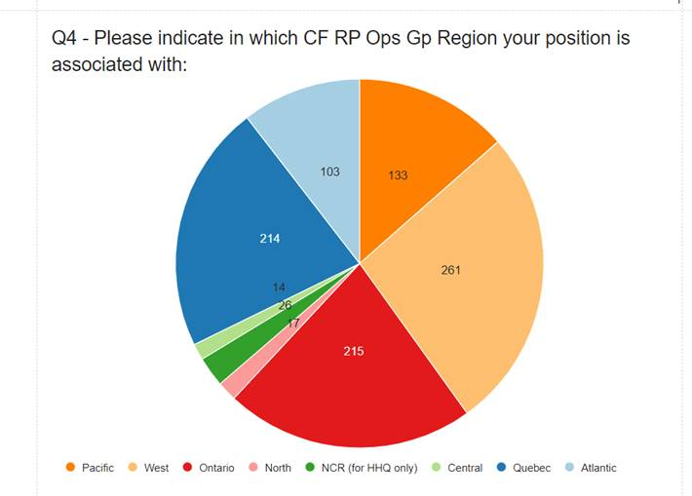

MOOSEJAW – CAE(CMAT) Contract: UNDE highlighted concerns in the manner that the contract with CAE(MAT) / ATCO in Moose Jaw are being manage. It was noted that ADM(IE) does not have a role in managing these contracts. UNDE stated that they should be aware of what is happening to these UNDE private sector members that work at 15 Wing Moose Jaw in support of the military and public service employees.

CF RP OPS GP EHS Council: Col Henley has found these meetings extremely beneficial in highlight shortfalls and gaps within the Formation and identifying trends that are developing. Union representatives to continue to attend.

Col Horgan’s Retirement he stated the employees of ADM(IE) are doing the very best with the resources and personnel available. With the limited resources it is important to be smart about the investments that are being made for the real property assets. Together, the Union and management can be a strong advocate for more resources to help mitigate the challenges to deliver the best possible infrastructure program possible for the CAF.

Beaver Tales As Commander of the Canadian Forces Real Property Operations Group (CF RP Ops GP), I would like to thank ADM(IE) for allowing me the opportunity to provide the introduction to this edition of Beaver Tales. This month’s edition will have an RP Ops focus and, as such, I would like to specifically acknowledge all the writers from the CF RP Ops Gp for their regular contributions to Beaver Tales – the articles are truly outstanding!

Agenda for meeting on 01 Dec 22 UMCC:
- Budget/SWE
- Moving of other funds to SWE
- Apprenticeship Funding
- Standby pay
- Staffing summary/vacancy report
- Deloitte final report
- TOR finalized
- New CAE (CMAT) contract sub-contractor SERCO with sub-contractor CBO
- Strategic Review NCR

Respectfully submitted by
Mona Simcoe Marcelo Lazaro
VP MB/Sask VP BC
Co-Chair

