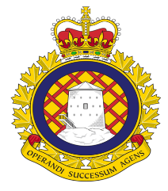 Atlantic RPOU LMCC

LCol LeGresley chaired the LMCC October 18, 2022.
The chair reminded everyone about RPOU Digital Suggestion Box and that a video will be released shortly on how to use it. Suggestions can have your name attached or can be anonymous.
Also, a reminder of the new HR Staffing Planning (MPPT-Master Projected Planning Table) that can be seen on SharePoint. This is only for the Atlantic Regional RPOUs, showing all positions funded, unfunded and classifications.
The Deloitte Study is completed, and draft report will be reviewed by the CO and OCs then released.
They are in the process of moving Vote 5 funding to SWE L111. Vote 5 project money has SWE attached which is what will be moved, but unsure if this can be done annually.
Essential Service lists were sent up and now back for review.
It was asked if we could have written reports for the HR and LRO updates and have them prior to the meeting.
COVID protocols, we have moved into a new phase with RPOU following directive from the Bases and Wings.
LCol LeGresley will arranging an Atlantic Town Hall for RPOU staff-MTF
EAP mentioned that Gagetown and Goose Bay need Peer Advisors, presently there are none.
Respectfully,
Craig Smith/Daniel Frost


