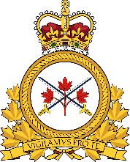 COMMANDER OF THE ARMY LMCC

There was no UMCC during this period, scheduled for Monday November 28th, 2022.
Major General St-Louis has been posted to Washington, DC and Lieutenant General Paul is now the Commander of the Army.

Respectfully,
Daniel Frost
Gerald Grenon
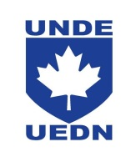
VP NL/NB

